# Creating a Java Project

Step 1: Select a work space

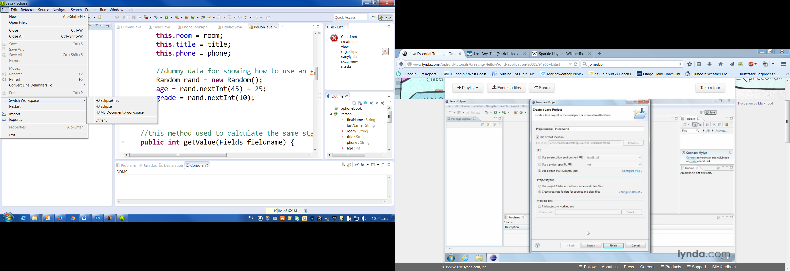

Step 2: Create a project:

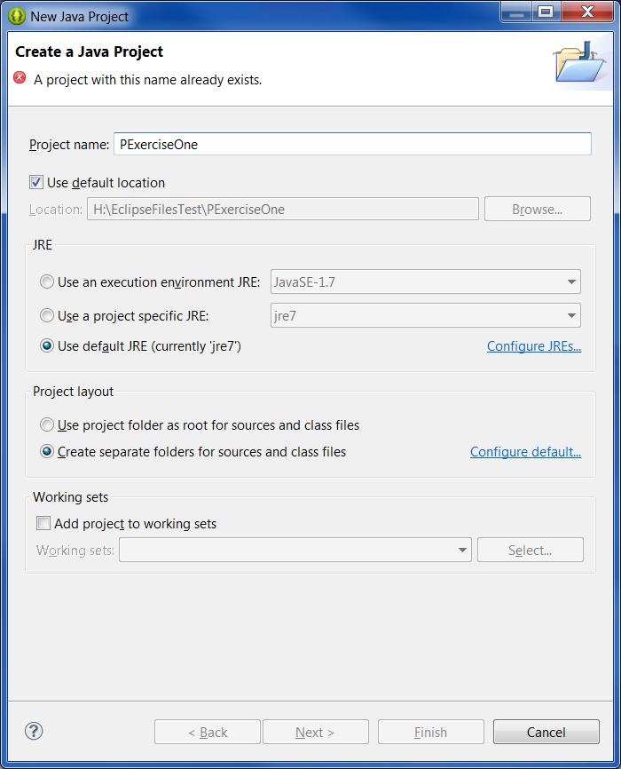

Step3: RC on project node and create new Java Class

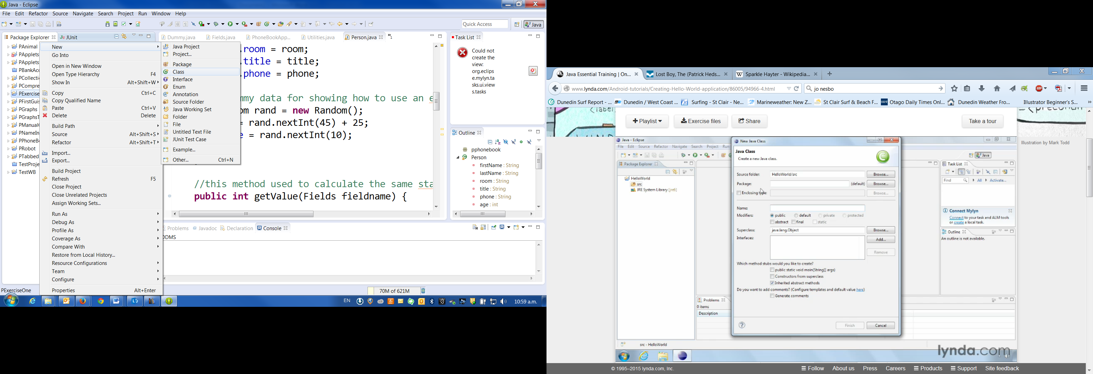

Step 4: Give it a package name the same as the project name but in lowercase, call any class that has the main method in it an App class (ie tag the word App to the end of the class name)

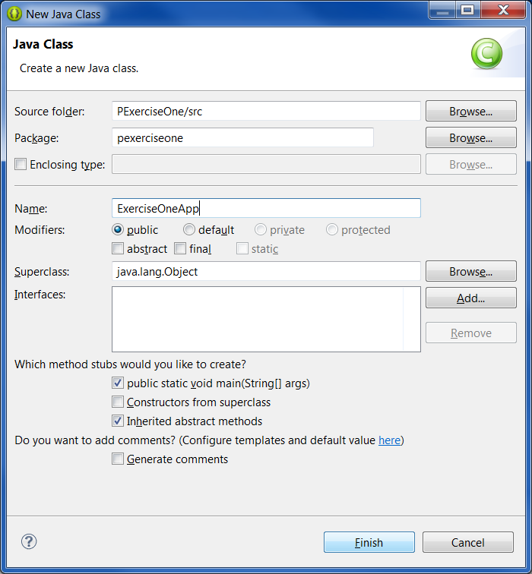

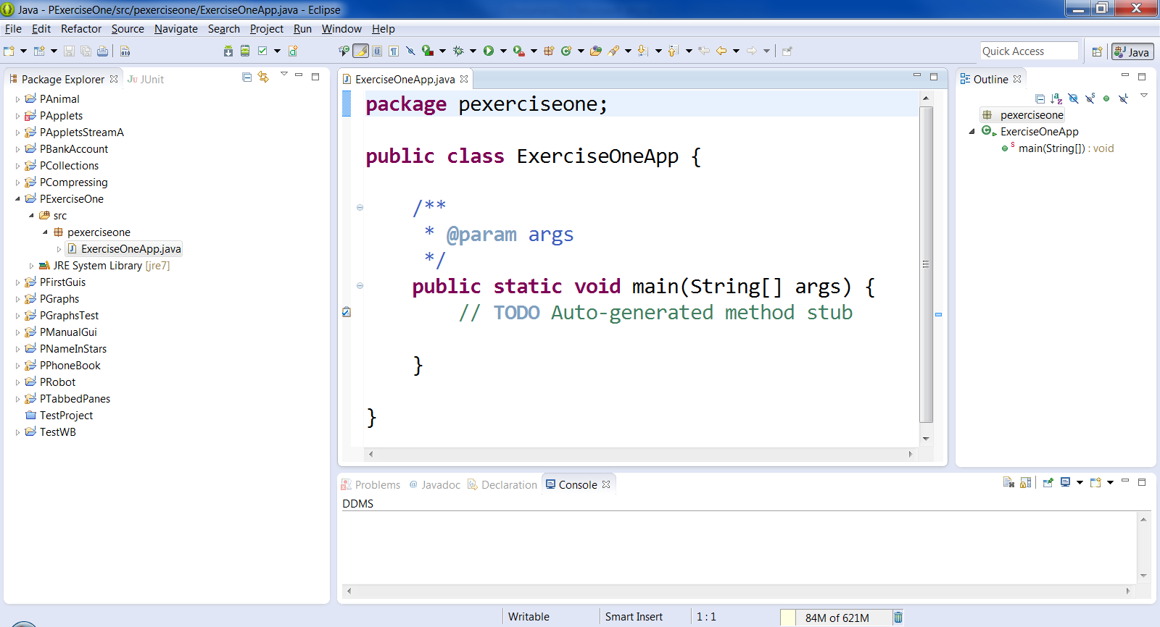Finally this is how the project should look.